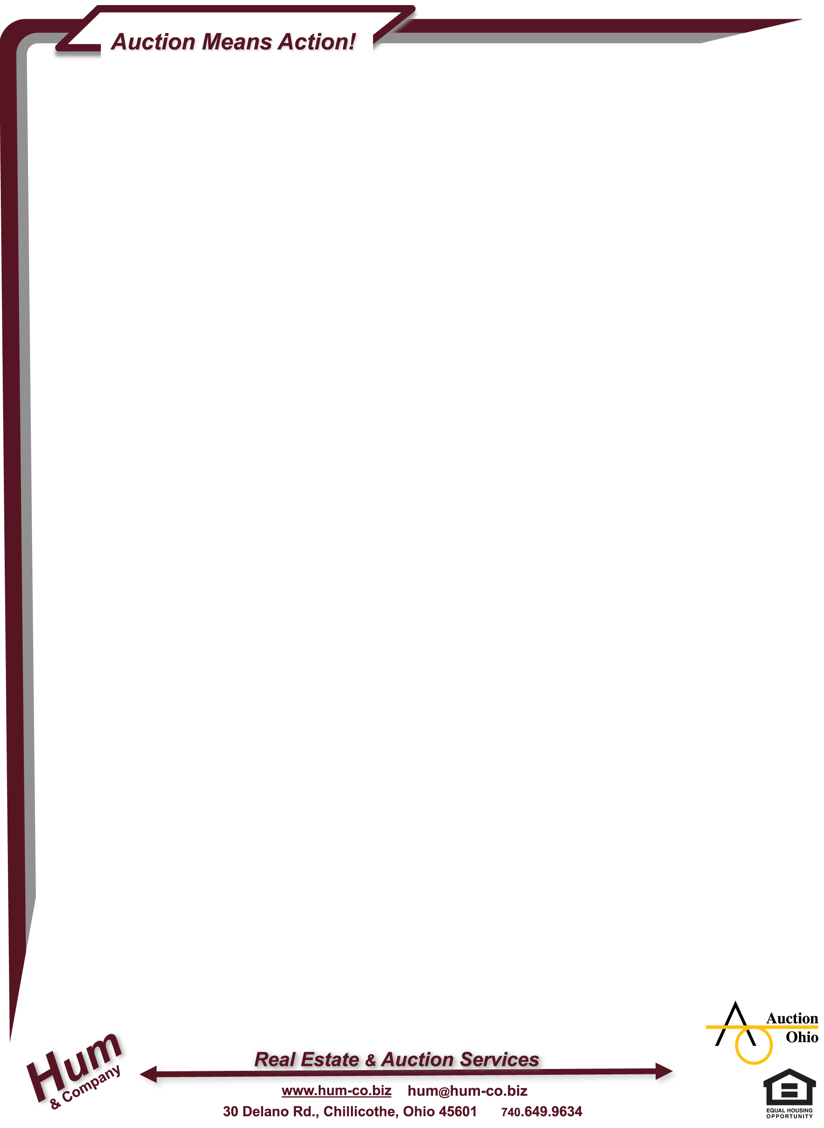

LIVE & ONLINE (Simulcast) AUCTION!

ONLINE Bidding Now!!

All 40 Items located @ 400 E. 7th St., Chillicothe

Previews Thursday 24 Oct @ 3 - 5pm

Saturday 02 Nov @ 11am – 1pm

On-site LIVE Auction Thursday 07 Nov @ 11am

Online Primary Pickup Friday 08 Nov @ 11am – 2pm

Alternate Live/Online Pickup by Friday 15 Nov @ Noon
Auctioneer Team Representing the Seller:
Steve “Hum” Hummel, Auctioneer
740.649.9634
hum@hum-co.biz

Auction Manager
Keith Alcorn 740.656.7390
Additional Auctioneers:
Dan DeGarmo, Roger Parsons, Tom Rawn

Pictures, Descriptions, Terms & Details @ www.auctionohio.com

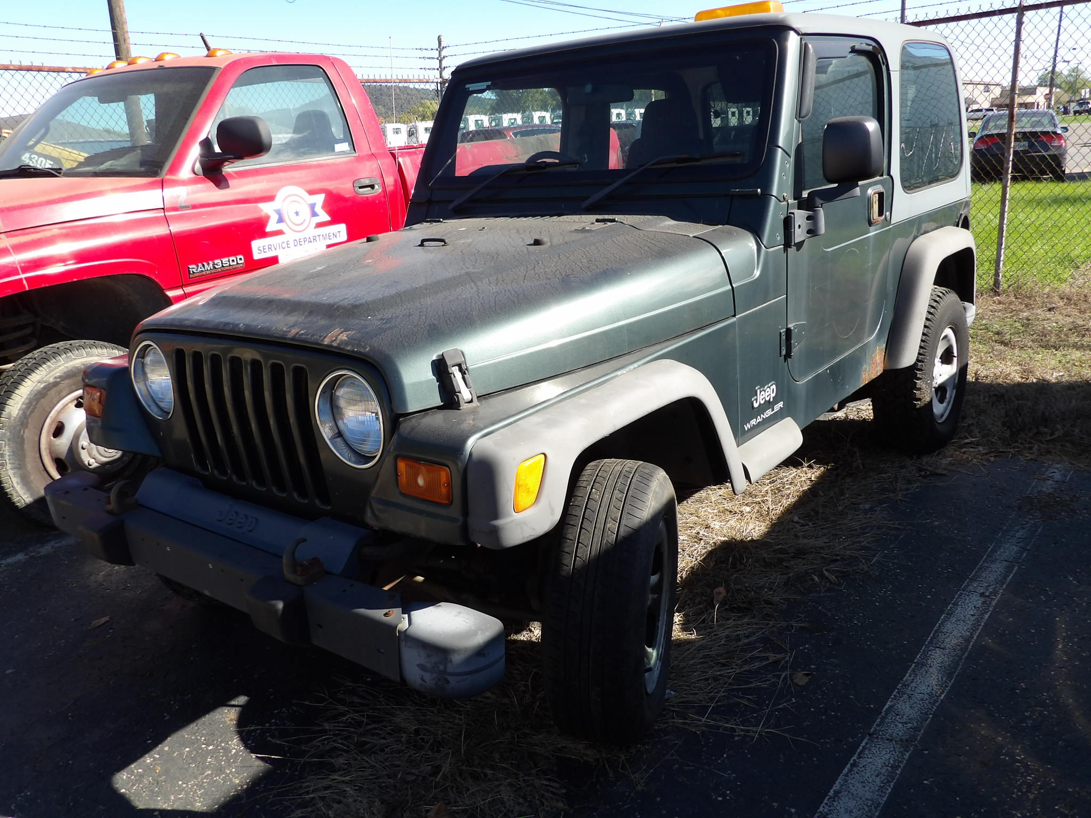 | 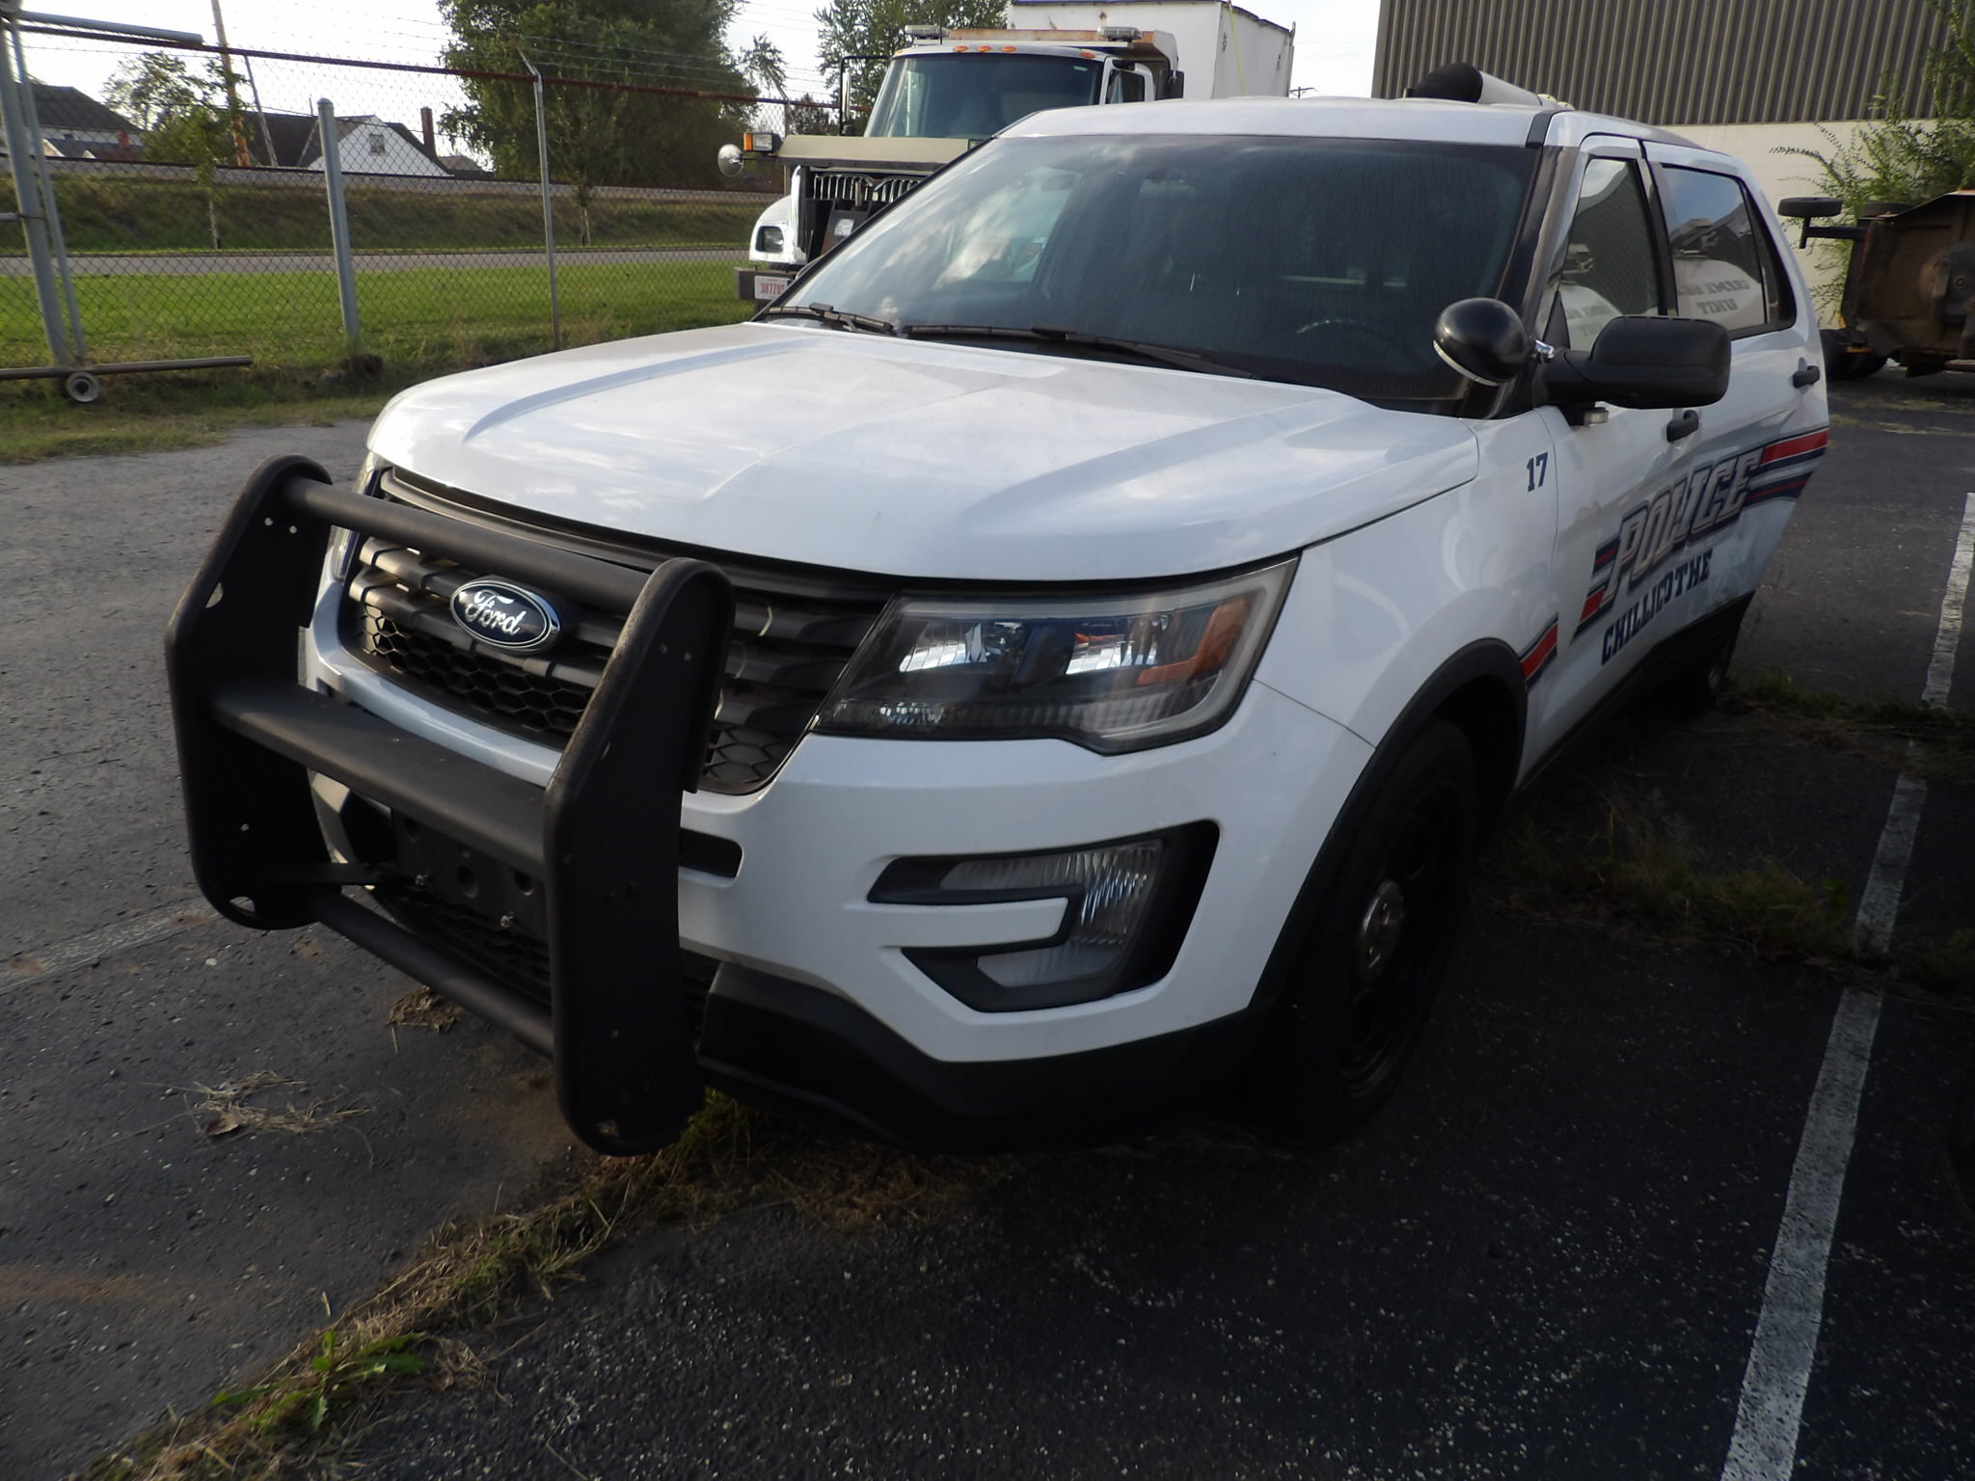 | 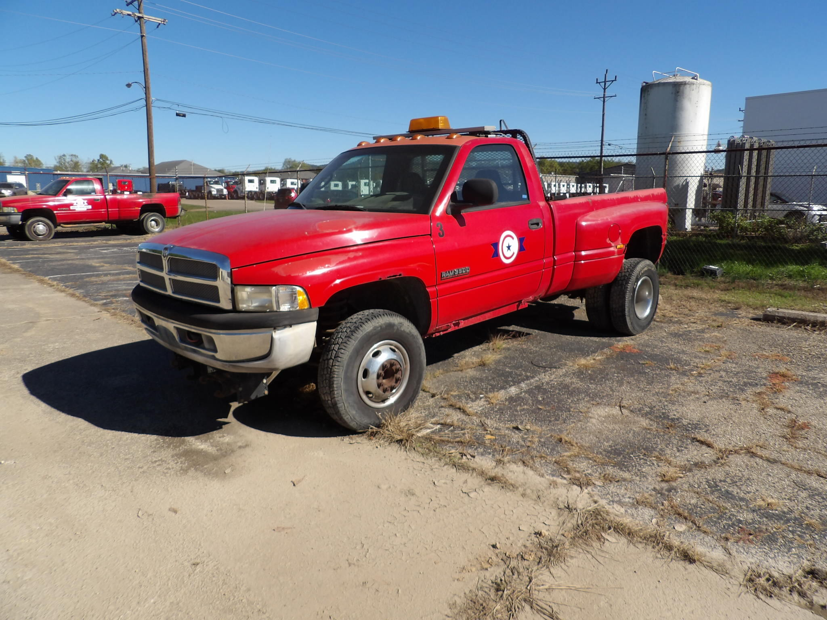
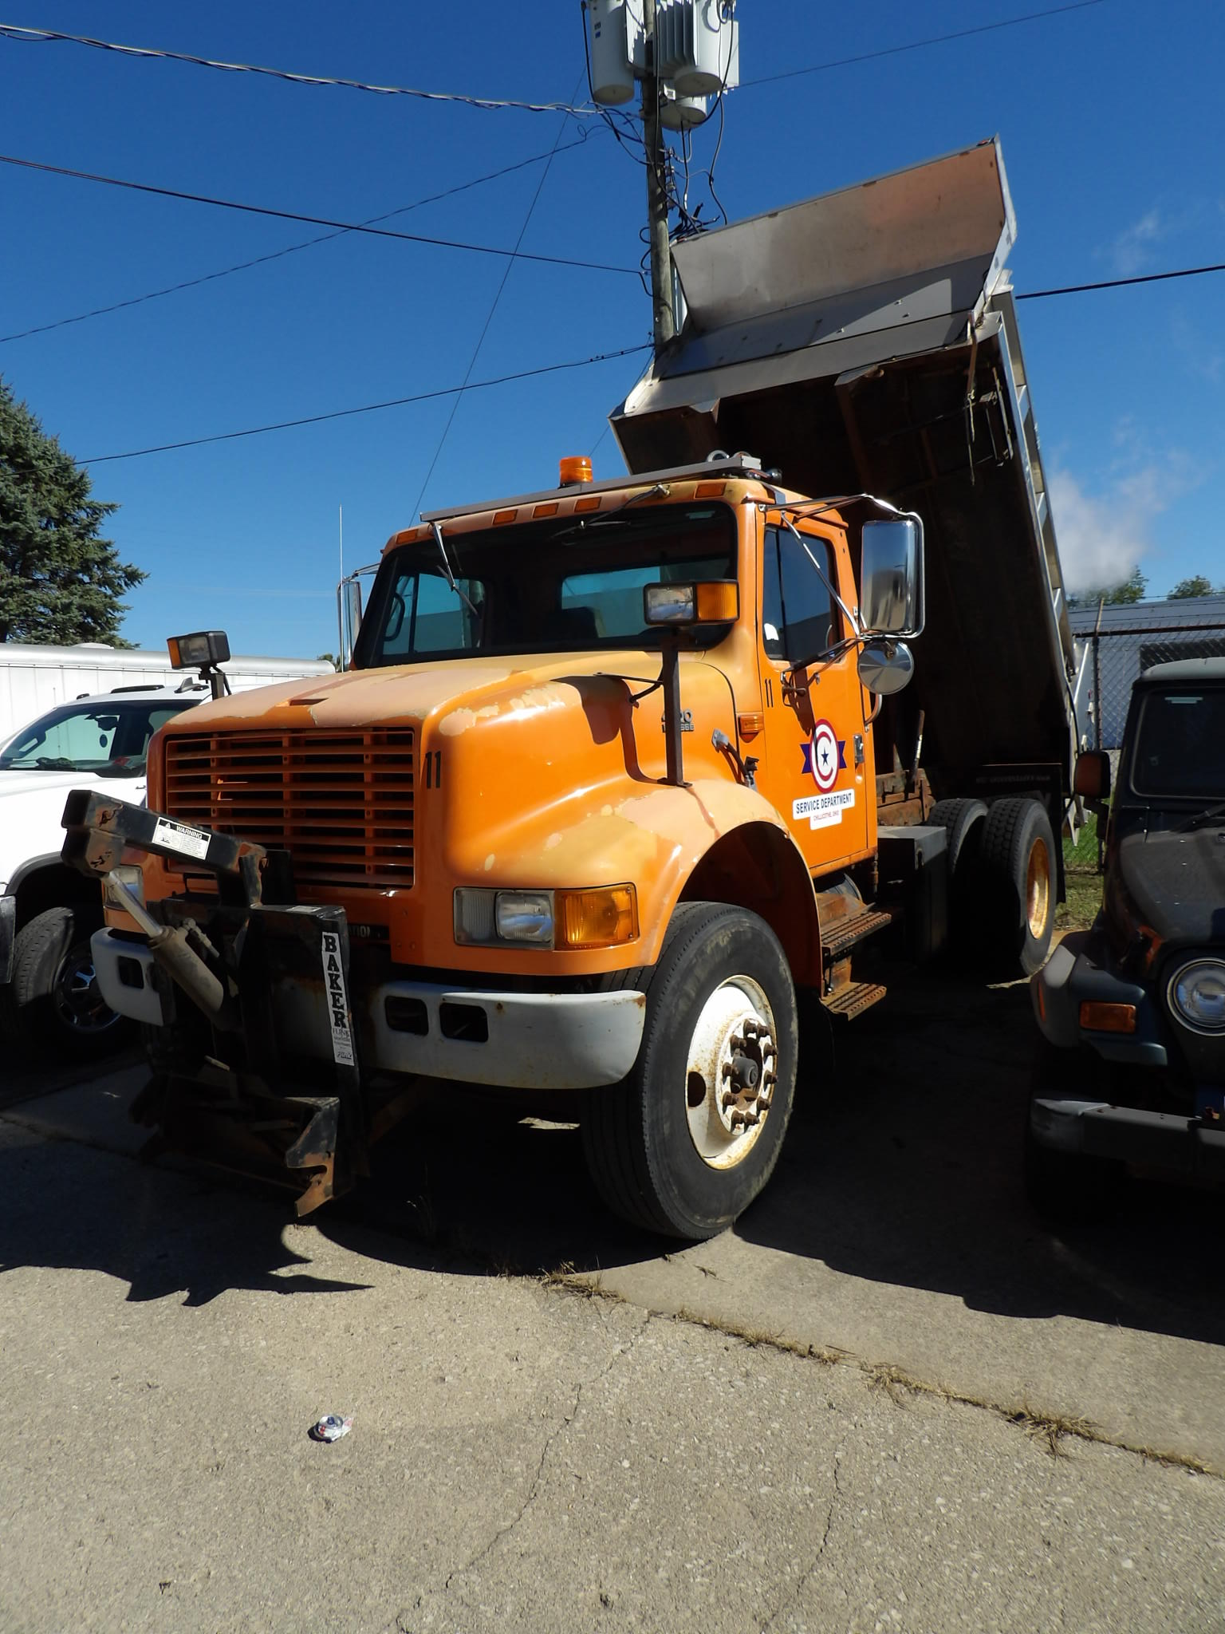 | 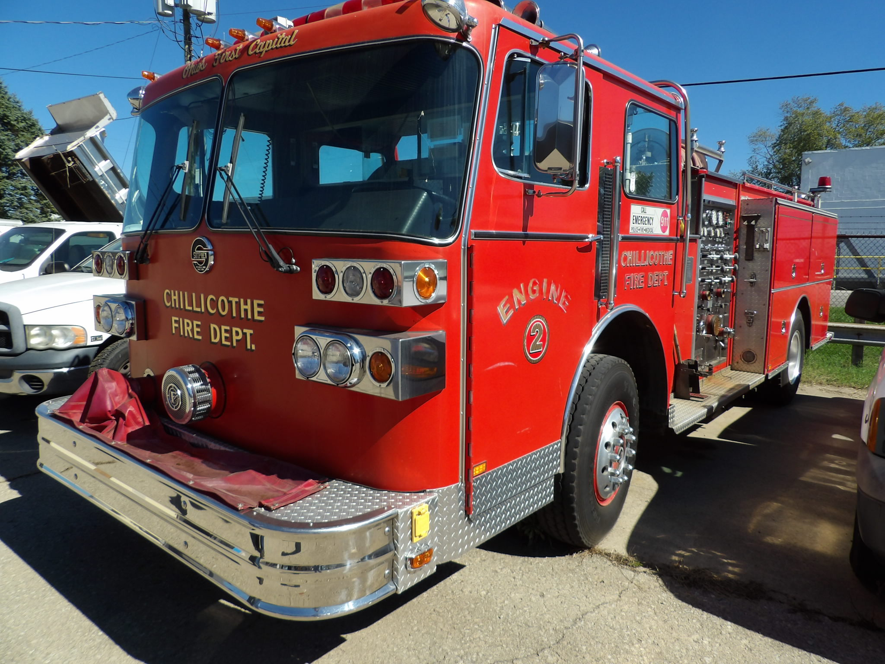 | 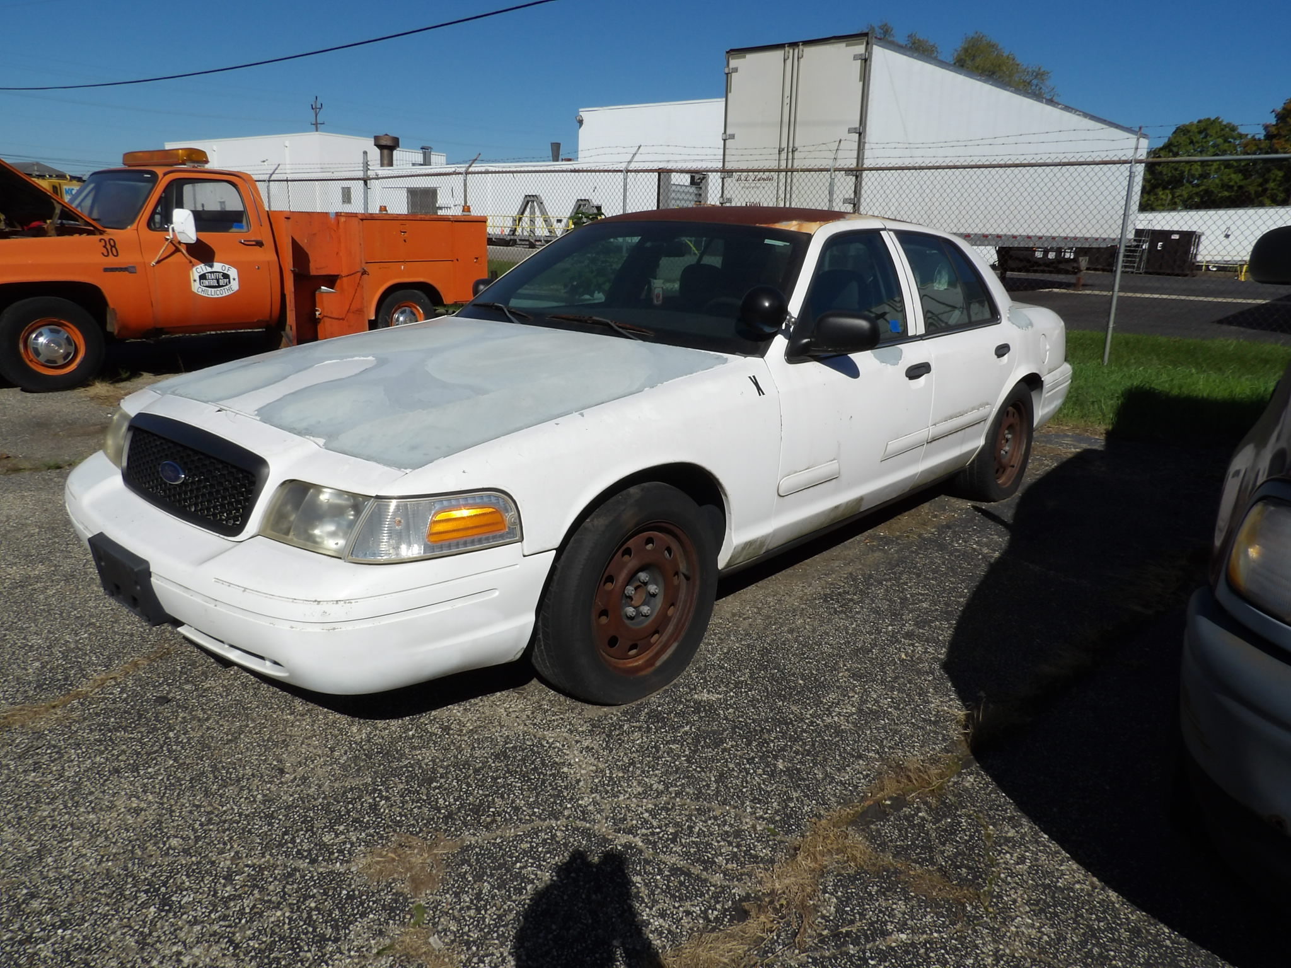
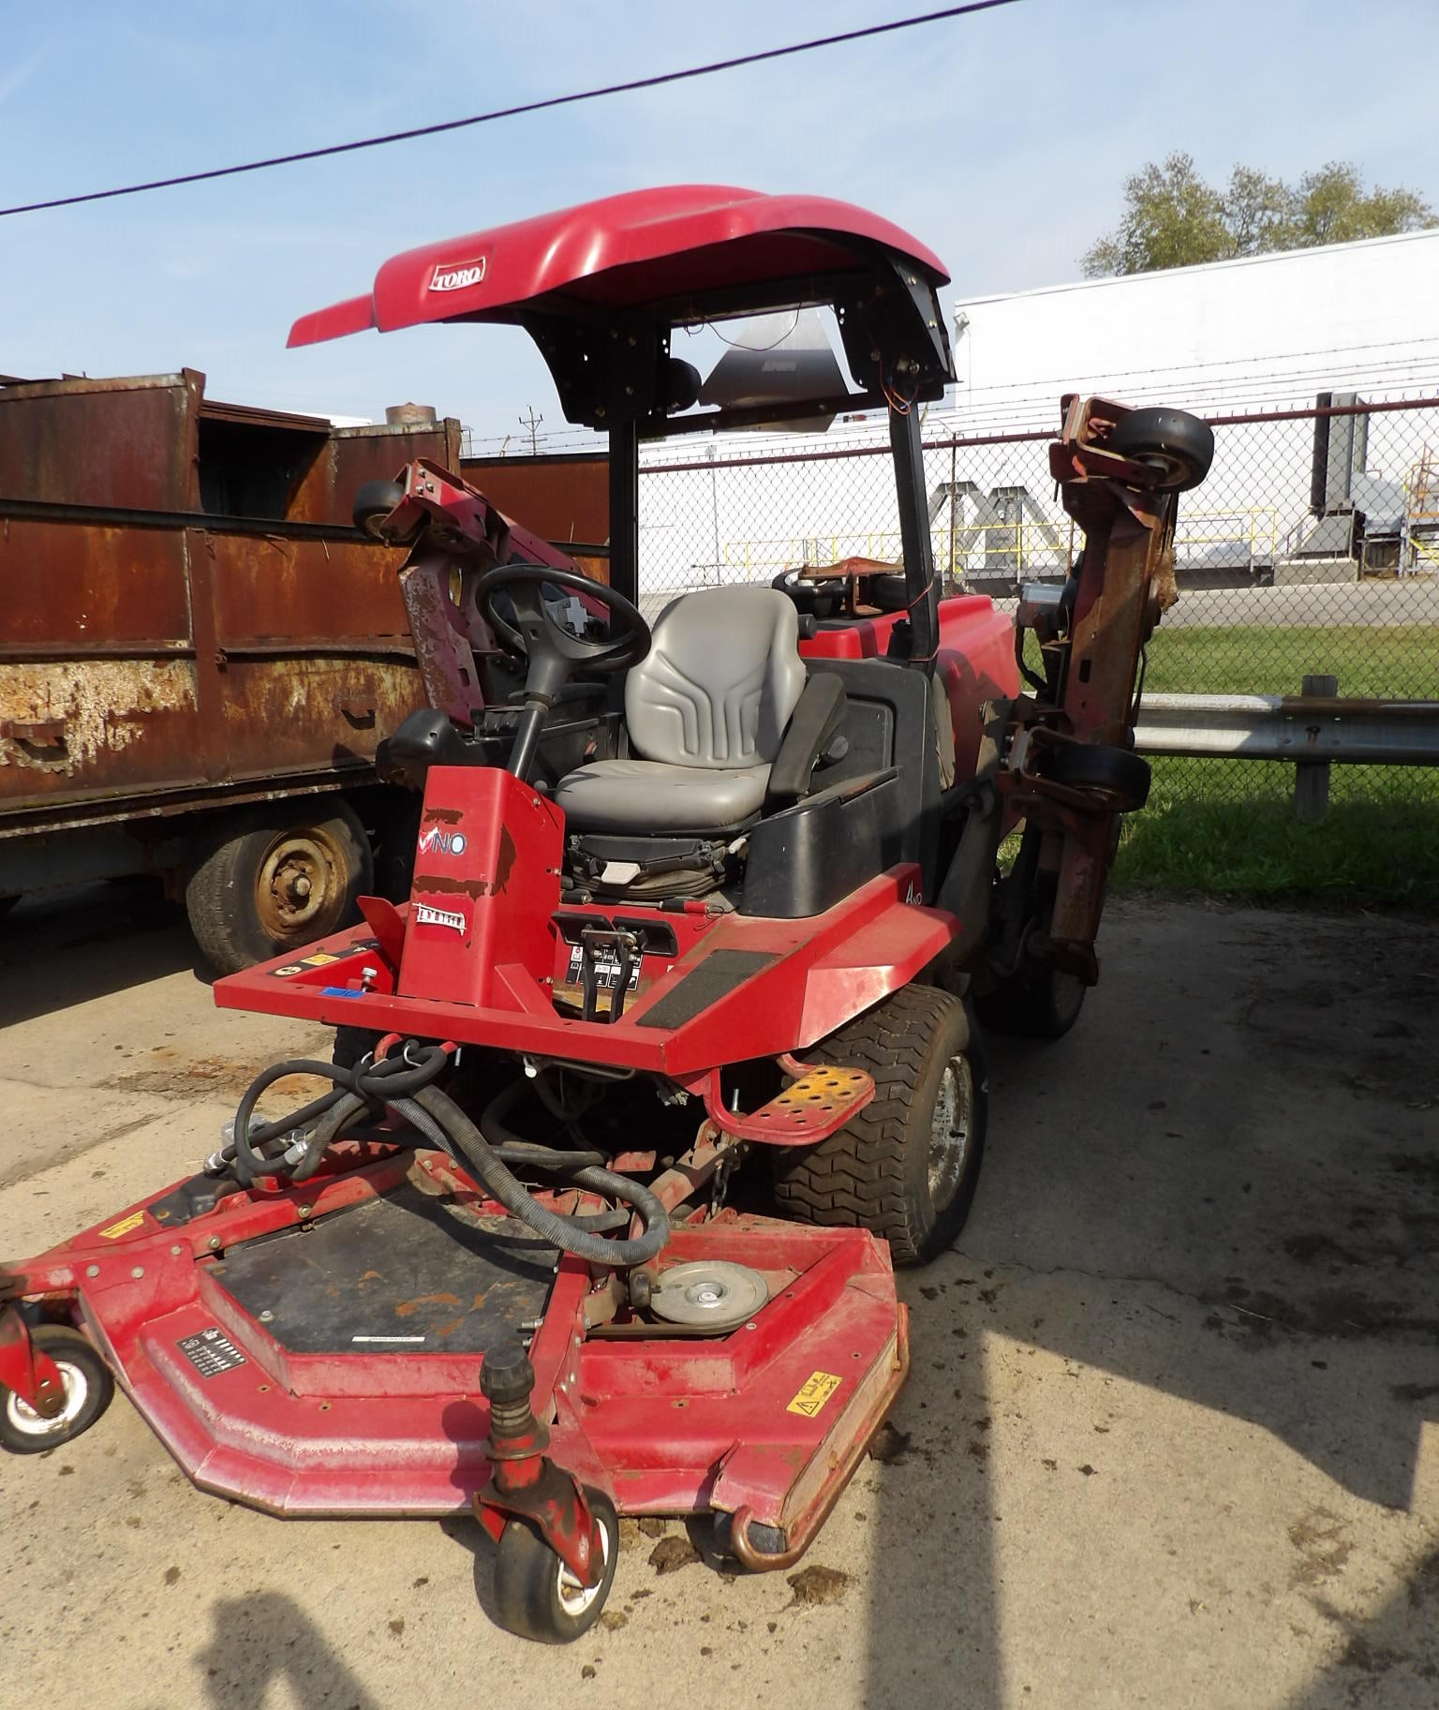 | 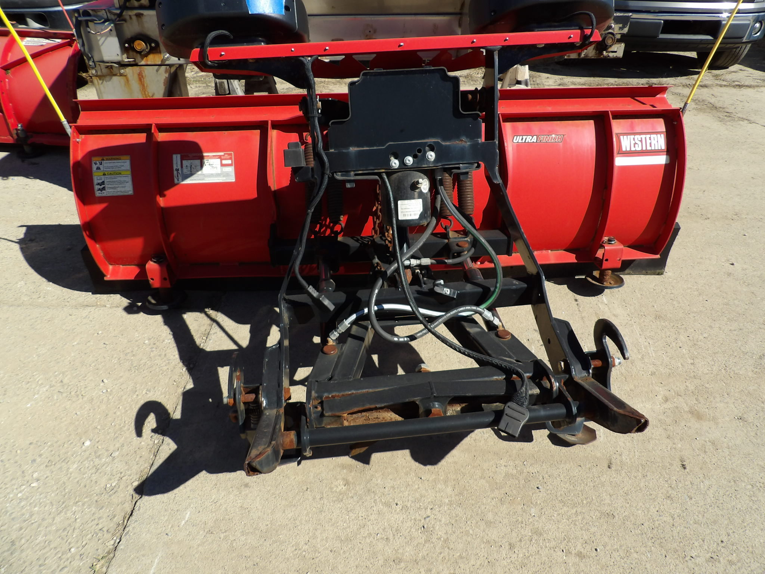 | 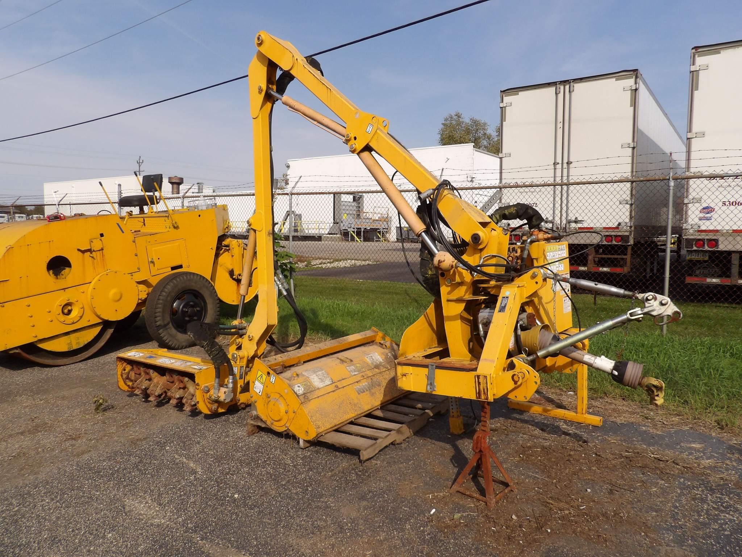

City Equipment!
246 Pawnee Rd., Chillicothe, Ohio 45601

